

Observations Policy - Minimum Standards for Monitoring and Recording Adult Physiological Vital Signs

Version: | V2.0
Ratified by: | Healthcare Governance Committee
Date ratified: | 24 August 2012
Name of originator/author/job title: | Sr. Elaine Grainger, Lead Nurse. Critical Care Outreach Team  Dr Indeewar Kapila, Clinical Director.  Critical Care Outreach Team
Name of responsible committee/individual: | Health Care Governance Committee
Date issued: | September 2012
Review date: | July 2014
Target audience: | Foundation Trust wide

EQUALITY IMPACT STATEMENT

The Trust strives to ensure equality of opportunity for all both as a major employer and as a provider of health care. This Policy Document has therefore been equality impact assessed by the Health Care Governance Committee to ensure fairness and consistency for all those covered by it regardless of their individual differences, and the results are shown in Appendix D.

University Hospital of South Manchester NHS Foundation Trust
VERSION CONTROL SCHEDULE

Version number | Issue Date | Revisions from previous issue | Date of approval by Committee
1.0 | March 2010 |  New Policy | January 2010 HCGC
2.0 | Sept 12 | Amendments to Section 3 and 4 – Audit  Saturations of 96% and above score 0 on the MEWS  Appendix A showing new oxygen saturation parameters  Inclusion of audit tool and criteria Appendix D | 19 July 2012
DOCUMENT CONTROL

Summary of consultation process | Expert and Stakeholders consulted Section 8.0 p14
Control arrangements  [Reviews shall generally be undertaken every 2-3 years or more frequently to take account of organisational learning] | Minimum requirement to be monitored  6 monthly audits of all adult wards. Audit Criteria and Tool p21 Section 4 p 12  Section 5 p12  Frequency of monitoring  Quarterly reports to the Patient Safety and Quality Board. Bi-Monthly reports to Acute Care Management Group Annual Report to Health Care Governance Committee
Associated documentation and references | p15, 17 and 18

Contents

Paragraph |  | Page
1 | Introduction | 4
2 | Purpose | 4
3 | Duties | 4
3.1 | Duties within the Organisation | 5
3.2 | Observation Policy - Minimum Standards for Monitoring and Recording Adult Physiological Vital Signs. | 6
4 | Process for monitoring compliance to the Observation Policy - Minimum Standards for Monitoring and Recording Adult Physiological Vital Signs | 11
5 | Standards/key performance indicators and process for monitoring compliance | 12
6 | Dissemination, Implementation and Access to this Document | 12
7  8 | Review, Updating and Archiving of this Document Expert and Stakeholder Involvement | 13  14
9 | References | 14
10 | Associated Documentation | 17
11 | Appendices | 17
 | Appendix A Modified early warning score tool and MEWS Escalation Strategy | 18
 | Appendix B Variance Form | 19
 | Appendix C Summary of standards/key performance indicators  Appendix D Audit Tool and Criteria  Appendix E Equality Impact Assessment Tool  Appendix F Plan for dissemination of policy or procedural documents | 20
23
24
25

1.0 | Introduction
1.1 | Although the close monitoring and recording of patients physiological vital signs is paramount in the early detection of acute illness, this basic skill is often neglected by health care workers. The National Institute for Health and Clinical Excellence (NICE CG50 2007) has produced evidence which suggests that patients who are, or become acutely unwell in hospital may receive suboptimal care. This may be due to their deterioration not being recognised, or despite patients exhibiting signs of clinical deterioration it is sometimes not appreciated, or acted upon quickly enough.
1.2 | NICE also highlight that communication and documentation between the multi-disciplinary team is often poor, experience might be lacking and provision of critical care expertise, including admission to critical care areas, delayed.
1.3 | This policy states the minimum standards required from clinical staff that record and document adult patient physiological vital signs. Patients admitted to the Foundation Trust will feel confident that if they are acutely unwell or their condition deteriorates, they are in the best place to receive prompt, effective and safe care.
2.0 | Purpose
2.1 | The purpose of this policy is to outline the minimum standard expected from all clinical professionals in the routine monitoring and recording of adult physiological vital signs when a clinical decision has been made to admit to The Foundation Trust. Practitioners are also directed to additional standards and parameters that may apply in specific clinical circumstances in addition to routine monitoring. However, to discuss all possible clinical circumstances is beyond the scope of this policy and the frequency of observations may differ in some patients and locally agreed guidelines should be followed in these instances.  For example;  - patients during the first 24 hours of the post operative period  - patients on transfusions of blood products  - patients with any type of analgesia infusions ( for example epidurals, PCAs etc)  - patients on drug infusions requiring specific observations  - patients nursed within Theatres  - patients nursed in a level 2/3 (Critical Care) bed  - Maternity  - Paediatrics
3.0 | Duties

3.1 | Duties within the Organisation
3.1.1 | Chief Executive and Board of Directors have overall responsibility for ensuring the requirements within this policy are fulfilled and that all operational responsibilities are in place by carrying out an overview of significant risks via the Risk Advisory Committee. In addition appropriate equipment must be provided to enable clinical staff to take and record Adult Physiological Observations.
3.1.2 | The Executive Medical Director is responsible for ensuring that the requirements set out in this Policy are fulfilled.
3.1.3 | Associate Director of Operations will oversee the application of this Policy into the clinical practices of their services.
3.1.4 | Consultant As the professional with the overall clinical responsibility for patients the Consultant will ensure that clinical standards are maintained and that any necessary deviation from this policy is documented and explained in the medical notes.  The Consultant will supervise medical staff in training to ensure that all patients have a documented medical management plan including frequency of observations. The Consultant will be responsible for setting goals and acceptable parameters to guide other clinical staff in their role of monitoring, interpreting and acting upon abnormal parameters.
3.1.5 | Heads of Nursing have a responsibility to ensure that this policy is disseminated to Matrons and Ward Managers to inform clinical staff of their responsibilities in the accurate recording of the MEWS and to act appropriately when patients begin to trigger.  In collaboration with Matrons and Ward Managers, Heads of Nursing must ensure that adverse clinical incidents in relation to physiological monitoring in their clinical areas are reported and investigated and action plans produced to prevent future occurrence.
3.1.6 | Matrons and Ward managers have a responsibility to ensure that any staff responsible for taking and recording observations are competent, able to calculate the MEWS accurately, suitably trained to recognise acute illness and knowledgeable in the MEWS Escalation Policy, to escalate care when needed to the appropriate people.  Matrons and Ward Managers have a responsibility to ensure that all clinical staff have access to appropriate monitoring equipment and that it is in working order and that the observation charts are available and located in close proximity to the patient at all times.
3.1.7 | Clinical Professionals involved in monitoring, recording, interpreting or acting on adult physiological observations have a personal and professional responsibility to ensure   that they are competent, within their scope of professional practice, to accurately undertake and record physiological vital signs in accordance  with this policy

acknowledge any limitations in their knowledge and competence and seek further training as appropriate
report any abnormalities or concerns to a more senior member of the team when appropriate
be competent in the use of equipment necessary for the taking and recording of adult physiological observations
be able to report any malfunctions to the Medical Technical Services department
be aware of the MEWS Escalation Policy when patients begin to trigger on the Modified Early Warning Score tool (MEWS)
 what actions are needed by the range of scores generated (A summary of the MEWS Escalation Policy is located on the Adult Observation Chart booklet and the full policy is available on the Trust Intranet http://uhsm- intranet/policies/Pages/default.aspx
Report any untoward incident that occurs by not adhering to this Policy by informing their line manager and using the HIRS reporting system.
3.1.8 | Clinical Director Critical Care Outreach Service and Critical Care Outreach Lead have responsibility for auditing the Observation Policy to ensure that clinical practitioners comply with this policy
3.1.9 | Medical Technical Services Department have a responsibility to check and maintain physiological measurement equipment in accordance with hospital policy and manufacturers recommendations
3.2 | Observation Policy - Minimum Standards for Monitoring and Recording Adult Physiological Vital Signs
3.2.1  3.2.2 | All adult patients admitted into the Foundation Trust, (including patients in Accident and Emergency and Outpatients Departments when a decision has been made to admit) will have a Trust observation chart commenced and physiological observations recorded at the time of their admission. Each basic set of observations must include;  Respiratory rate Temperature  Blood pressure  Pulse – rate and regularity  AVPU score (Conscious level) Oxygen saturation  Mode of oxygen delivery  Modified Early Warning Score (MEWS) (appendix A)  In specific clinical circumstances, additional monitoring must be considered

and the decision documented clearly within the medical notes. For example; Blood sugar
Urine output/fluid balance Hourly urine output
Pain assessment Sepsis screen
Neurological observation chart (Glasgow Coma Score)
Weight
(this is not an exhaustive list)
3.2.3 | All adult patients admitted into the Foundation Trust, including those deemed medically fit or in a rehabilitation environment, must have observations undertaken 12 hourly as a minimum standard unless a decision has been made at a senior level to increase or decrease this frequency for an individual/group of patients. Any alteration to the minimum standard must be documented in the medical notes.
3.2.4 | Any patients following emergency admission or inpatients who are becoming acutely unwell must have their frequency of observations increased in accordance with the Trust MEWS Escalation Policy for the Management of Acutely ill Adult Patients, (and section 3.2.9 and 3.2.10 of this policy).
3.2.5 | Any patient admitted via the Accident and Emergency Department must have their observations recorded a minimum of 4 hourly for the first 24 hours of admission unless specified otherwise by ST3 level and above. Any variance to this minimum standard must be documented clearly in the patients’ medical notes.
3.2.6 | Patients discharged from a higher level of care, i.e. ICU/HDU, will have their observations recorded a minimum of 4 hourly and a strict fluid input and output chart, for the first 48 hours on a general ward.
3.2.7 | A clear monitoring and management plan which also specifies frequency and type of observations to be recorded, must be completed by the admitting or reviewing medical practitioner. This must be done on initial assessment or admission and written clearly in the patients medical notes. The plan should take into account the patients diagnosis, agreed treatment plan and presence of co morbidities.
3.2.8 | Exceptions to this minimum standard must be considered at an early stage and established for patients who are acutely ill but will not benefit from an escalation of therapy beyond ward based care, any decisions must be clearly documented in the medical notes. If a decision has been made that therapy will not be escalated beyond ward based care and, even with maximum medical management, the patient continues to deteriorate then a decision must be made:    on the patients resuscitation status  or to commence the Trust Care of the Dying Pathway

 | Please refer to the Trust Resuscitation Policy and Do Not Attempt Resuscitation Policy on the Trust Intranet. http://uhsm- intranet/policies/Pages/default.aspx
3.2.9 | NCEPOD have also produced a recent document regarding decisions made around cardiac arrest to guide clinicians regarding resuscitation decisions. http://www.ncepod.org.uk/2012cap.htm  The frequency of observations will also be determined by the Registered Nurse in conjunction with the Modified Early Warning Score Tool (MEWS) used within the Trust (appendix A).  Therefore if the patient scores a:  No Score 0: record observations minimum of 12 hourly Low Score 1- 2: record observations minimum of 4 hourly  Medium score 3- 6: record observations minimum of 1 hourly High Score 7 or more: record observations minimum of every 30 minutes
3.2.10 | When a patient begins to trigger on the MEWS, the Foundation Trust MEWS Escalation Policy must be followed to escalate care. A summary of this is located on every Adult Patient Observation Chart booklet and the full procedure can be found following this link http://uhsm- intranet/policies/Pages/default.aspx (See appendix A)  In some circumstances, patients who are acutely unwell will not trigger on the MEWS. It is therefore important that clinical staff will also use their clinical judgement in deciding the frequency of observations recorded especially when there is any clinical concern that the patient is becoming unwell.  Other scoring systems can also be used within the Trust, for example CURB 65; however, these must be used in conjunction with the MEWS and not as an alternative.
3.2.11 | The first set of observations recorded on the observation chart at the start of each day will show the date clearly.
3.2.12 | All entries on the observation chart must;  Specify the actual time the observations were undertaken. Be initialled by the person carrying out the observations.  Include the respiratory rate counted over one minute.  Include oxygen saturation. (Refer to the Trust Oxygen Policy for appropriate action if not within normal parameters for that patient Pages - MedicinesManagementPolicies)  Include the mode of oxygen delivery when a patient is receiving oxygen therapy. This will be recorded using the key located on the

Adult Observation Chart booklet. This key is based on recommendations by the British Thoracic Society to clarify to clinical staff what must be documented on the observation chart; this reduces any ambiguity in recording the mode of oxygen delivery. Any patient receiving oxygen therapy must have this prescribed and reference should be made to the Target Saturation Scheme within the Foundation Trust Oxygen Policy.
Include the pulse (heart rate) documented in graph form and not numerically.
Include the heart rhythm. This will be a manual pulse taken over one minute to assess the characteristic of the heart rhythm, then documented as regular (R), or irregular (I) on the observation chart. If continuous ECG monitoring is used document the appropriate rhythm recorded.
Include systemic blood pressure. In cases of very low blood pressure (< 90 Systolic) electronic devises will be inaccurate and a manual blood pressure using a sphygmomanometer must be carried out. Manual sphygmomanometers will be available to all areas and staff should be competent to use them. This must be charted in graph form and not numerically unless the systolic BP is greater than 240mmhg.
Include temperature. Method of temperature recording will be assumed to be oral unless otherwise stated and will be recorded in degrees centigrade.
Include level of consciousness using the AVPU score, where
- 0 = A- Alert
- 2 = V- rousable to voice
- 3 = P- rousable to pain
- 3 = U - unrousable
If a patient has developed new confusion or agitation this will be recorded as 1 on the observation chart in line with the MEWS. Patients scoring a P or U must be given medical help immediately, their airway is at risk. Consider calling 2222 if the patient is still for resuscitation.
A Trust Neurological Observation Chart (Glasgow Coma Score (GCS)) must be commenced for patients scoring a P or U on the MEWS and frequency of observations as per NICE CG 56 (see 3.2.13)
3.2.13 | All patients who have sustained a head injury before or during admission to the Foundation Trust must have a neurological observation chart commenced, unless a senior Medical Practitioner has made a decision that this is not required. Any decisions must be documented in the medical notes.  Frequency of neurological observations will be based on NICE guidelines  NICE clinical guideline on the triage, assessment, investigation and early

management of head injury in infants, children and adults - NeLM which recommend;
Perform and record observations on a half hourly basis until GCS = 15
When GCS = 15, minimum frequency of observations is
- Half- hourly for 2 hours
- Then 1 hourly for 4 hours
- Then 2 hourly thereafter
- If patient deteriorates to GCS<15 after initial 2 hour period, revert back to half-hourly observations
- Frequency of observation as per MEWS when stable
Any deviation from this minimum standard must be decided by a senior medical practitioner and documented in the medical management plan.
3.2.14 | Variance Forms  In certain clinical conditions patients normal physiological parameters could trigger inappropriately on the MEWS, indicating an unnecessary increase in frequency of observation. In these cases, a variance to this standard may be authorised by a Doctor or Nurse in Charge of the ward. This variance must then be clearly documented on the front of the Adult Observation Chart Booklet and a Variance Form completed and inserted into the patients’ observation Booklet. (See appendix B and section 5.0 of the MEWS Escalation Policy).  This will guide staff taking and recording the observations in these particular patients when to increase or decrease the frequency of observations and when to escalate their care. (See sections 3.2.8 and 3.2.9 of this policy for exceptions to this variance).  These forms are to be used for patients with an ongoing chronic condition and must not be used for patients with a sudden acute onset of illness.
3.2.15 | Fluid balance charts must be completed for the following patients, unless a medical practitioner or a registered nurse has made a decision otherwise. The rational for this variance must be documented in the patients medical/nursing notes;    Scoring 3 or more on the MEWS All emergency hospital admissions Post operative patients.  Exceptions may include  - day case patients,  - patients having minor surgical/medical procedures  - short stay patients  However, in these cases a fluid balance chart must be commenced if


clinical staff feel there is a clinical need. Whose temperature is greater than 38C
Experiencing any excessive fluid loss from, for example, surgical drains/cavity drains, for example naso gastric tubes, underwater seal drains, ascitic drains, ileostomy, nephrostomy

On a restricted fluid intake
Nil by mouth more than 12 hours With vomiting and or diarrhoea
Receiving Intravenous fluid therapy, IV medications or parenteral nutrition
With known or suspected renal impairment or cardiac conditions i.e. those with an upward trend in urea and creatinine, with an electrolyte imbalance etc
With urinary catheters, except for those patients with long-term catheters who do not have an acute onset of illness.
Who are not catheterised and it is documented on the observation chart that they have not passed urine in the last 12 hours.
Discharged from ICU/ HDU for a minimum of 48 hours post discharge.
All sickle cell disease patients should have a carefully maintained fluid balance chart for the duration of their admission. (NCEPOD 2008)
This is not an exhaustive list and there may be other indications for commencing a fluid balance chart.
At midnight all fluid balance charts must be totalled to show the daily fluid balance and a cumulative fluid balance recorded to show the collective balance.
4.0 | Process for monitoring compliance to the Observation Policy - Minimum Standards for Monitoring and Recording Adult Physiological Vital Signs.
The CCOT Lead will be responsible to ensure that an audit of compliance to this policy is conducted on a six monthly basis as per Trust Clinical Audit Policy. Additionally other data will be used where available and will be incorporated into the audit reports, for example local audits of compliance undertaken by ward managers.
Every adult ward will be audited using a sample of 10 random patients, the audit template in appendix D will be used to gather this data
Results of the audits will be discussed with appropriate Matrons and Ward Managers who will develop action plans to address any issues highlighted during the audit process. The action plans will be disseminated to the following groups;
Healthcare Governance Committee Patient Safety and Quality Board.
Senior Nurses, Matrons, Ward Managers
NHSLA Compliance Manager

5.0 | Standards/key performance indicators and process for monitoring compliance
Key performance indicators for the Observational Policy are detailed as follows and will be reviewed during audit. The target for achieving compliance with these key indicators is 100%. (A summary of these key indicators are located in Appendix C)
All patients admitted into UHSM Foundation Trust will have a Trust observation chart.
All Adult patients to have a medical management plan recorded stating frequency of observations on admission.
Adult in patients to have observations undertaken 12 hourly as a minimum standard (exceptions to this standard refer to section 3.2.8, and 3.2.9 of this policy)
Frequency of observations determined by the MEWS, unless a decision has been made to increase or decrease frequency of observations
0: minimum 12 hourly observations
1-2: minimum 4 hourly observations
3-6: minimum 1hourly
7 or more :minimum every 30 minutes Entries on the observation chart to be dated.
All entries on the observation chart to specify the actual time the observations were undertaken.
Each set of observations to include
- respiratory rate
- pulse (graph form)
- Heart rhythm (characteristic of the pulse, i.e. regular, irregular)
- systemic blood pressure (graph form not numerical)
- level of Consciousness (AVPU)
- temperature (graph form)
- oxygen saturation
- mode of oxygen delivery
- an accurate Modified Early Warning Score Each set of observations to be initialled
A fluid balance form to be commenced if scoring 3 or more on the MEWS
6.0 | Dissemination, Implementation and Access to this Document will be in accordance with the rules set out in the Trusts Policy on Policies (see appendix G)
6.1 | Dissemination  All Senior staff listed in section 3.1 (i.e. Chief Executive, Clinical

Directors, Heads of Nursing and Matrons etc) will receive an electronic copy of this policy for dissemination at all appropriate Trust and Divisional meetings to ensure that all relevant staff are made aware of the key principles of this policy.
The Outreach Lead will organise awareness sessions for all practice educators within the trust who will then disseminate this to clinical staff on their designated wards. The Outreach Team will provide training for any wards without a practice educator.
All Ward managers must allocate time for staff to attend these awareness sessions
It is the responsibility of individual clinical staff to ensure they attend the awareness sessions, and a record of attendance will be recorded by the practice educators/Outreach Lead and logged with the Training Department.
Awareness sessions will be held in various locations around the trust to all clinical staff involved in taking, recording and analysing Adult physiological observations including ward sessions, road shows, Staff Pledges, poster displays etc.
Global email will be sent Trust wide
Presented by Outreach Team at all Trust Inductions
6.2  6.3 | Implementation  The policy was originally implemented on 14th January 2010 Access  The policy will be available on the Foundation Trust Intranet  Key points of this policy will be located on the Adult Observation Chart booklet, Fluid Balance Charts and Neurological Observation Charts, which will be kept at the patient’s bedside at all, times for ease of access.
7.0 | Review, Updating and Archiving of this Document
7.1  7.2  7.3 | Review  This policy will be formally reviewed in July 2014. The review will be initiated by the author of this policy  Updating  This policy will be updated if any new evidence is produced or by any substantial change in national policy.  Archiving  The process for archiving will be in line with the procedure as described in  10.2 and 10.3 of the Arrangements for the Development and Approval of Foundation Trust-wide Policies or procedural documents policy available on  the Trust Intranet.

8.0 | Expert and Stakeholder Involvement  The following people have been involved in developing this policy; Elaine Grainger, CCOT Lead  Dr Indeewar Kapila, Clinical Director CCOT  Critical Care Outreach Team: Gail Sharpe, Jenny Treacy, Katie Dickinson, Kellie Catterall.  Resucitation Team: Maresa Johnson, Louisa Riley, Dr Mark Patrick Helen Rodgers, Patient Safety and Quality Manager  Acute Care Management Group Heads of Nursing  Matrons  Ward Managers  Practice Based Educators
9.0 | References
 | Marsden Manual 7th edition. UHSM intranet
 | National Patient Safety Agency (2007). Recognising and responding to early signs of deterioration in hospitalised patients.
 | NCEPOD (2005) An Acute Problem? A report of the National Confidential Enquiry into Patient Outcome and Death.
 | NCEPOD (2009) Caring to the end? A review of the care of patients who died in hospital within four days of admission
 | NICE (2007) Acutely Ill Patients in Hospital: Recognition of and response to acute illness in adults in hospital. NICE guideline 50
 | NICE (2007) Head Injury – triage, assessment, investigation and early management of head injury in infants, children and adults. NICE guideline 56
 | NMC (2002) Guidelines for records and record keeping
 | NPSA (2007) Safer Care for the Acutely Ill Patient: learning from serious incidents
 | O’Driscoll et al (2008) Guideline for emergency oxygen use in adult patients. British Thoracic Society
 | Patient Safety First Campaign (2008) www.patientsafetyfirst.nhs.uk
 | Survive Sepsis Campaign www.survivingsepsis.org
 | UHSM (2008) Oxygen Prescribing and Administration Policy (Appendix 15 of Medicines Management Policy)

UHSM (2010) MEWS Escalation Policy.
Andrews, T., Waterman, H. (2005) Packaging: a grounded theory of how to report physiological deterioration effectively. Journal of Advanced Nursing; 52: 5, 473-481.

Buist, M.D. et al (1999) Recognising clinical instability in hospital patients before cardiac arrest or unplanned admission to intensive care. A pilot study in a tertiary-care hospital. The Medical Journal of Australia; 171: 1, 8-9.

Butler-Williams, C. et al (2005) Increasing staff awareness of respiratory rate significance. Nursing Times; 101: 27, 35-37.

Chellel, A. et al (2002) Nursing observations on ward patients at risk of critical illness. Nursing Times; 98: 46, 36-38.

Critical Care Stakeholder's Forum and National Outreach Forum (2007) Clinical Indicators for Critical Care Outreach Services. www.dh.gov.uk

Cuthbertson BH, Bourjerdi M, Aucott L, Prescott G. Can physiological variables and early warning scoring systems allow early recognition of the deteriorating surgical patient? Crit Care Med (2007) 35:402–9.

Department of Health (2005) Quality Critical Care - Beyond 'Comprehensive Critical Care'. www.dh.gov.uk

Department of Health (2004a) National Standards, Local Action: Health and Social Care Standards Planning Framework 2005/6-2007/8).www.dh.gov.uk

Department of Health (2004b) Standards for Better Health. www.dh.gov.uk

Department of Health (2004c) The NHS Improvement Plan: Putting People at the Heart of Public Services. www.dh.gov.uk

Department of Health (2003) Critical Care Outreach: Progress in Developing Services. www.dh.gov.uk

Department of Health (2000) Comprehensive Critical Care: A Review of Adult Critical Care Services.www.ics.ac.uk

Gao H, McDonnell A, Harrison DA, et al. Systematic review and evaluation of physiological track and trigger warning systems for identifying at-risk patients on the ward. Intensive Care Med (2007) 33:667–79.

Esmonde L, McDonnell A, Ball C, et al. Investigating the effectiveness of critical care outreach services: a systematic review. Intensive Care Med (2006) 32:1713–21.

Goldhill, D.R., Sumner, A. (1998) Outcome of intensive care patients in a group of British intensive care units. Critical Care Medicine; 26: 8, 1337- 1345.

Goldhill, D.R. et al (1999) Physiological values and procedures in the 24

hours before ICU admission from the ward. Anaesthesia; 54: 6, 529-534.

Goldhill, D.R., McNarry, A. (2002) Intensive care outreach services. Current Anaesthesia and Critical Care; 13: 6, 356-361.

Hillman, K.M. et al (2001) Antecedents to hospital deaths. Internal Medicine Journal; 31:6, 343-348.

Hillman, K.M. et al (1996) Identifying the general ward patient at risk of cardiac arrest. Clinical Intensive Care; 7: 242-243.

Intensive Care Society (2002) Guidelines for the Introduction of Outreach Services.www.ics.ac.uk

McGloin, H. et al (1999) Unexpected deaths and referrals to intensive care of patients on general wards. Are some cases potentially avoidable? Journal of The Royal College of Physicians of London; 33: 3, 255-259.

McQuillan, P. et al (1998) Confidential inquiry into quality of care before admission to intensive care. British Medical Journal; 316: 7148, 1853-1858.

NCEPOD (2005) An Acute Problem? www.ncepod.org.uk

NCEPOD (2008) A Sickle Crisis? www.ncepod.org.uk

NICE (2007) Acutely Ill Patients in Hospital: Recognition and Response to Acute Illness in Adults in Hospital. www.nice.org.uk

National Patient Safety Agency (2007a) Safer Care for the Acutely Ill Patient: Learning from Serious Incidents. 5th Report from the Patient Safety Observatory. www.npsa.nhs.uk

National Patient Safety Agency (2007b) Nutritional Screening: Structured Investigation Project. www.npsa.nhs.uk

O'Riordan, B. et al (2003) Implementing a critical care course for ward nurses. Nursing Standard; 17: 20; 41-44.

Parissopoulos, S., Kotzabassaki, S. Critical Care Outreach And The Use Of Early Warning Scoring Systems; A Literature Review ICUS NURS WEB J issue 21January – march 2005

Patient Safety First Campaign (2008) The ‘how to guide’ for Reducing Harm From Deterioration. www.patientsafetyfirst.nhs.uk

Schein, R. et al (1990) Clinical antecedents to in-hospital cardiopulmonary arrest. Chest; 98: 6, 1388-1392.

Sherman, F.T. (2002) Vital signs are still- well, vital. Geriatrics; 57: 3, 9.

Smith, G. et al (2006) Hospital-wide physiological surveillance - a new approach to the early identification and management of the sick patient.

Resuscitation; 71: 1, 19-28.

Smith, G. (2000) Alert Life-threatening Events. Recognition and Treatment: A Multi-professional Course in Care of the Acutely Ill Patient: Course Manual. Portsmouth: Portsmouth Institute of Medicine, Health and Social Care Faculty of Science.

Tarassenko L, Hann A, Young D. (2006) Integrated monitoring and analysis for early warning of patient deterioration. Br J Anaesth 97:64–8.
National Confidential Enquiry in to Patient Outcome and Death (2012) Time to Intervene. NCEPOD. London
British Thoracic Society (2008) Emergency Oxygen use in Adult Patients. www.brit- thoracic.org.uk
9.0 | Associated Documentation
Resuscitation Policy
Do Not Attempt Resuscitation Policy MEWS Escalation Policy
Clinical Audit Policy
10.0 | Appendices

Appendix A - Modified Early Warning Score Tool and Mews Escalation Strategy
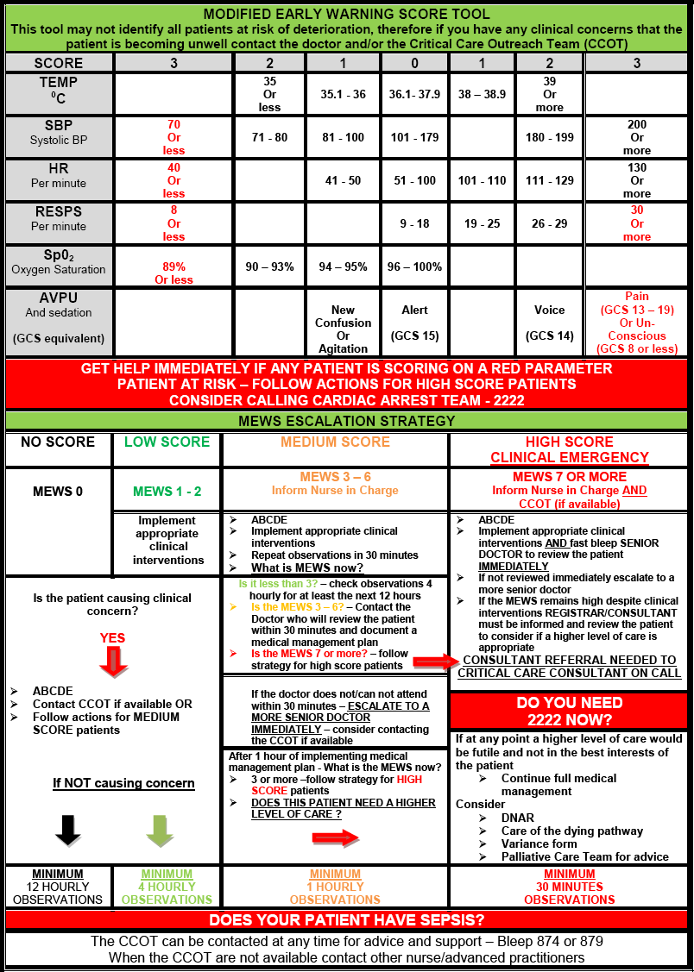

Appendix – B Variance Form
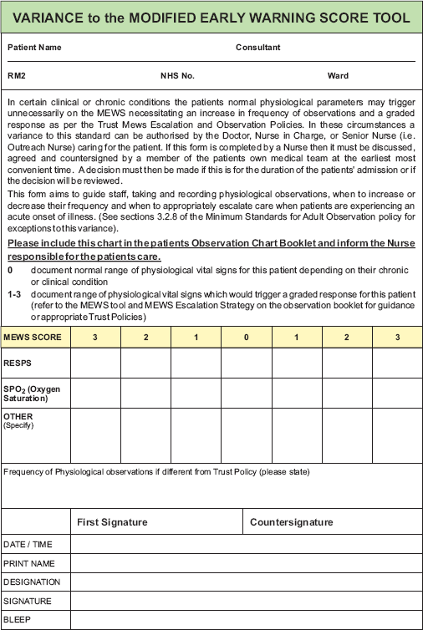

Appendix C - Summary of Standards/Key Performance Indicators
Audit Tool - Observation Policy - Minimum Standards for Monitoring and Recording Adult Physiological Vital Signs.

No | Care (Standard) | Responsibility | Standard | Exceptions | Target
1 | All patients admitted into UHSMHT must have a Trust observation chart. | Registered Nurse | Observation chart is present for this admission | None | 100%
2 | All adult in patients to have observations undertaken 12 hourly as a minimum standard | Ward / Unit manager  Registered Nurse | Documented evidence on the Observation Chart.  Variance form | Patients exempt from this standard are:  On the Care of Dying pathway  Patients with a Variance Form completed | 100%
3 | Patients discharged from a higher level of care ie ICU/HDU should have their observations recorded 4 hourly for the first 48 hours | Ward / Unit manager  Registered Nurse | Documented evidence on the Observation Chart. | Documented evidence form a Critical Care Doctor that this would not be appropriate  On the Care of Dying pathway | 100%
4 | Frequency of observations to be determined by the Registered nurse in conjunction with the Modified Early Warning Score (MEWS) guidelines. However the patient should have a minimum of:  12 hourly when MEWS 0  4 hourly when MEWS 1-2 1hourly when MEWS 3-6 every 30 minutes when MEWS 7 or more | Ward / Unit manager  Registered Nurse (RN)  Medics | To be decided by the:    RN  Medics | - First 24 hours post operative period  - Patients receiving blood products  - Patients with any types of analgesia infusions (ie epidurals/PCA etc)  - Patients on drug infusions requiring specific observations.  - Variance Form | 100%
5 | Entries on the observation chart to show clearly the date the observations were recorded. | Ward Manager  Registered Nurse  Recorder of the observations | Documented evidence on the observation chart that the date is entered on the first set of observations each day. | None | 100%

6 | All entries on observation chart to specify actual time observations were undertaken. | Ward Manager Registered Nurse Recorder of the observations | Documented evidence on the observation chart that all entries specify time. | None | 100%
7 | Each set of observations to include respiratory rate and documented in graph form. | Ward Manager Registered Nurse Recorder of the observations | Recorded evidence on the observation chart that respiratory rate has been taken. | None | 100%
8 | Each set of observations to include pulse documented in graph form. | Ward Manager Registered Nurse Recorder of the observations | Recorded evidence on the observation chart that pulse has been taken. | None | 100%
9 | Each set of observations to include systemic blood pressure. | Ward Manager Registered Nurse Recorder of the observations | Recorded evidence on the observation chart that blood pressure has been monitored. | None | 100%
10 | Each set of observations to include Level of Consciousness using the AVPU scale | Ward Manager Registered Nurse Recorder of the observations | Recorded evidence on the observation chart that conscious level has been monitored | None | 100%

11 | If AVPU = P or U a Trust neurological observation chart is commenced | Ward Manager Registered Nurse Recorder of the observations | Inclusion of a neurological observation chart in Adult Observation Chart booklet | None | 100%
12 | Each set of observations to include Temperature. | Ward Manager Registered Nurse  Recorder of the observations | Recorded evidence on the observation chart that Temperature has been monitored.  Documented method of temperature recording, assumed to be oral (unless  otherwise stated  e.g. axilla) | None | 100%
13 | Each set of observations to include oxygen saturation | Ward Manager Registered Nurse  Recorder of the observations | Recorded evidence on the observation chart that oxygen saturation has been monitored, and percentage of oxygen received. | None | 100%
14 | Each set of observations to include mode of oxygen delivery using the Key on the observation booklet | Ward Manager  Registered Nurse  Recorder of the observations | Recorded evidence on the observation chart that mode of oxygen delivery has been recorded. | None | 100%
15 | Each set of observations to include an accurate Modified Early Warning Score | Ward Manager  Registered Nurse  Recorder of the observations | Recorded evidence on the observation chart that Modified Early Warning Score has been calculated accurately. | All patients who have documented by a medical practitioner that they are being cared for on the care of the dying pathway | 100%

Appendix D – Audit Tool and Criteria
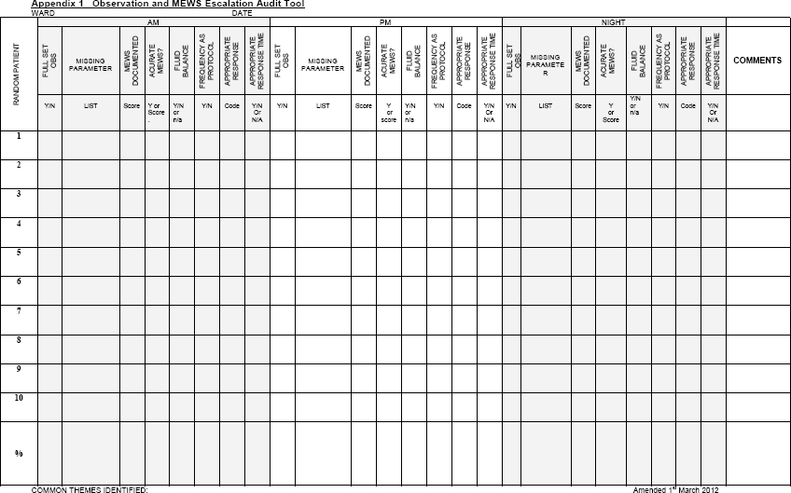

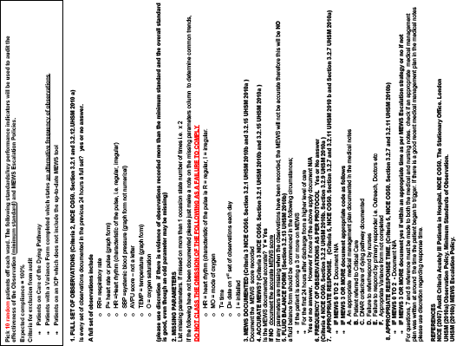

Appendix E - Equality Impact Assessment Tool
To be completed and attached to any procedural document when submitted to the appropriate committee for consideration and approval.

 |  | Yes/No | Comments
1. | Does the policy/guidance affect one group less or more favourably than another on the basis of:
 | Race | No
 | Ethnic origins (including gypsies and travellers) | No
 | Nationality | No
 | Gender | No
 | Culture | No
 | Religion or belief | No
 | Sexual orientation including lesbian, gay and bisexual people | No
 | Age | No
2. | Is there any evidence that some groups are affected differently? | No
3. | If you have identified potential discrimination, are any exceptions valid, legal and/or justifiable? | No
4. | Is the impact of the policy/guidance likely to be negative? | No
5. | If so can the impact be avoided? | No
6. | What alternatives are there to achieving the policy/guidance without the impact? | No
7. | Can we reduce the impact by taking different action? | No
If you have identified a potential discriminatory impact of this procedural document, please refer it to [insert name of appropriate person], together with any suggestions as to the action required to avoid/reduce this impact.
For advice in respect of answering the above questions, please contact [insert name of appropriate person and contact details].

Appendix F -Plan for Dissemination of Policy or procedural documents
To be completed and attached to any document which guides practice when submitted to the appropriate committee for consideration and approval.

Title of document: | Observation Policy
Date finalised: | July 2012 | Dissemination lead: Print name and contact details |  |  | Elaine Grainger Lead Nurse Outreach Team
Previous document already being used? | No  (Please delete as appropriate) |  |  |  | Elaine Grainger Lead Nurse Outreach Team
If yes, in what format and where?
Proposed action to retrieve out-of-date copies of the document:
To be disseminated to: | How will it be disseminated, who will do it and when? |  | Paper or  Electronic | Comments
Clinical Directors | Dr Indy Kapila.  Email copies to all Clinical Directors to disseminate to all Medical Teams |  | Electronic | No paper copies will be given.
All Trust staff | To be uploaded to the Policies section of the Intranet by the policy administrator. |  | Electronic | No paper copies will be given
 | To be publicised by global email by the Outreach Team Lead, |  | Electronic | No paper copies will be given
 | A link to the policy placed on the Acute Intensive Care Outreach Intranet page. |  | Electronic | No paper copies will be given
 | Managers required to disseminate to their staff via usual communication channels. |  | Electronic | No paper copies will be given
 | Practice Educators and members of the Outreach Team will train and educate ward staff |  | Electronic/Paper
 | At Trust Induction |  | Electronic

Dissemination Record - to be used once document is approved.

Date put on register / library of policy or procedural documents |  | Date due to be reviewed

Disseminated to: (either directly or via meetings, etc) | Format (i.e. paper or electronic) | Date Disseminated | No. of Copies Sent | Contact Details / Comments

